Peripheral Vision Validation

|  |  |
| --- | --- |
| Aspect | What was it for your investigation? |
| Hypothesis | Movement of objects can be detected at a greater angle than detection of colour of object. |
| Independent variable | Movement or colour recognition by eyes |
| Dependent variable | Angle of detection |

1. marks)
3. For this investigation what is the independent variable?

Difference in Age

(1mark)

1. What is the dependent variable?

The distance that the people could reach past their toes

(1 mark)

1. State a hypothesis for this investigation.

Older people will not be able to reach as far past their toes as younger people.

(2 marks)

1. Here are the results of this investigation.

Complete the table below

|  |  |  |
| --- | --- | --- |
| Name | Age  (years) | Flexibility  (cm) |
| John | 19 | 10 |
| Jim | 17 | 2 |
| Jenny | 18 | 7 |
| Jack | 18 | 12 |
| Annie | 19 | 9 |
| Total | | 40 |
| Average | | 8 |
| Craig | 41 | 0 |
| Sandy | 44 | 2 |
| Lam | 43 | 14 |
| Jasper | 41 | 4 |
| Rodd | 47 | 4 |
| Total | | 24 |
| Average | | 4.8 |

(1 Mark)

1. Draw a suitable graph of the results in the previous table.
2. marks)
3. How could the results have been made more accurate? (1 mark)

Increased sample size.

1. What is your conclusion for the experiment above?

The results support the hypothesis that older people cannot reach as far past their toes as younger people.

(1 mark)

1. Using the graph you drew, would it be possible to do accurate extrapolation for people of other age groups? Explain why.

NO(1 mark)

It should be a bar graph from which extrapolation is difficult.

(2 marks)

1. Use this graph to answer the questions that follow

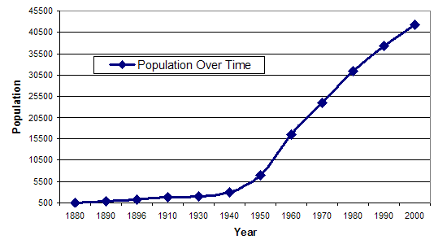

1. What will the population be in 2010?

50500

(1 mark)

1. Was your answer to question 3a an example of extrapolation or interpolation? Give a reason for your choice.

Extrapolation (1)

Was taken beyond the range of the known data(1)

(2 marks)

1. What was the population in 1965?

20500

(1 marks)

1. Was your answer to question 3c an example of extrapolation or interpolation? Give a reason for your choice.

Interpolation(1)

Taken from within the range of known/collected data.(1)

(2 marks)

1. Which was more likely to be correct, your answer to question 3a or 3c? Give a reason for your answer.

The answer to c/1965.(1)

The datat could change beyond the range of collected data(1)

(2 marks)

1. Look at the results below. They are the results for a test (experimental) sample group whose blood pressure was being observed after a 6 month training plan, where each person was made to walk for 1 hour a day. Use the data to answer the questions that follow.

|  |  |  |  |
| --- | --- | --- | --- |
| Name of test person | Age | Receiving blood pressure medication | Blood pressure  After 6 months training |
| Bob | 22 | No | 110/70 |
| Bill | 21 | No | 120/73 |
| Aaron | 23 | No | 122/70 |
| Jim | 58 | No | 124/80 |
| Jane | 23 | No | 130/70 |
| Jill | 21 | Yes | 117/70 |
| Sarah | 25 | No | 105/70 |
| Sammy | 20 | No | 120/70 |
| Jack | 22 | No | 114/70 |
| June | 21 | No | 160/90 |
| Terry | 22 | No | 126/70 |
| Trudy | 23 | No | 127/70 |

1. What is missing from the table?

(4 marks)

1. Which result appears to be an outlier? Give a reason for your choice.

(2 marks)

1. Apart from the outlier, which person should not have his/her results counted? Give a reason for your answer.

(2 marks)

1. What must be done with this data before constructing a graph of results? Why should this be done?

(2 marks)

/35 marks